VACUUM SENSOR PCB

- PARTS:

QUANTITY: PART #: NOMENCLATURE: LENGTH:

1 PER MACHINE 217075- PCB, BLANK, VACUUM SENSOR N/A

1 PER MACHINE 14048- CAP, ELEC, 2.2μF, 16V N/A

1 PER MACHINE 10443- IC, -MC34064 N/A

3 PER MACHINE 11089- TRANSISTOR, 2N3904, NPN N/A

1 PER MACHINE 16247- RESISTOR NETWORK, 10KΩ, 10-PIN N/A

1 PER MACHINE 13521- CAP, CER., .01μF, 50V N/A

2 PER MACHINE 13534- CAP, CER, 22pF, 50V N/A

1 PER MACHINE 18492- CRYSTAL, 4MHz, VP400 N/A

1 PER MACHINE 18702- LED, RED, LUMEX N/A

1 PER MACHINE 14032- CAP, 10μF, 25V N/A

3 PER MACHINE 17543-2 HEADER, 2-PIN, METHODE N/A

1 PER MACHINE 17543-3 HEADER, 3-PIN, METHODE N/A

.3 PER MACHINE 17594- CONNECTOR, 10-PIN N/A

1 PER MACHINE 18781- SENSOR, PRESSURE N/A

3 PER MACHINE 15390- RESISTOR, 56KΩ, ¼W, 5% N/A

2 PER MACHINE 15356- RESISTOR, 2.2KΩ, ¼W, 5% N/A

1 PER MACHINE 15424- RESISTOR, 10MΩ, ¼W, 5% N/A

1 PER MACHINE 15341- RESISTOR, 510Ω, ¼W, 5% N/A

1 PER MACHINE 15348- RESISTOR, 1KΩ, ¼W, 5% N/A

2 PER MACHINE 15372- RESISTOR, 10KΩ, ¼W, 5% N/A

1 PER MACHINE 17639-18 SOCKET, IC, 18-PIN N/A

1 PER MACHINE 18782- REGULATOR, POSITIVE, 5V N/A

1 PER MACHINE 18783- μCONTROLLER, 8-BIT, CMOS N/A

QUANTITY: PART #: NOMENCLATURE: LENGTH:

1 PER MACHINE 16304- RESISTOR, 150Ω, ¼W N/A

1 PER MACHINE 16305- RESISTOR, 750KΩ, ¼W N/A

- ASSEMBLY:

- INSERT AND SOLDER THE RESISTORS, ACCORDING TO DIAGRAM 1.

- INSERT AND SOLDER THE SMALL CAPACITORS, ACCORDING TO DIAGRAM 1.

- INSERT AND SOLDER THE RESISTOR NETWORK, ACCORDING TO DIAGRAM 1.

- INSERT AND SOLDER THE IC SOCKET, ACCORDING TO DIAGRAM 1.

- INSERT AND SOLDER THE TRANSISTORS, AND REGULATOR, ACCORDING TO DIAGRAM 1.

- INSERT AND SOLDER THE 3-PIN CONNECTOR, ACCORDING TO DIAGRAM 1.

- INSERT AND SOLDER THE LED, ACCORDING TO DIAGRAM 1.

- INSERT AND SOLDER THE TWO ELECTROLYTIC CAPACITORS, ACCORDING TO DIAGRAM 1.

- INSERT AND SOLDER THE HEADERS, ACCORDING TO DIAGRAM 1.

- INSERT AND SOLDER THE CRYSTAL, ACORDING TO DIAGRAM 1.

- INSERT AND SOLDER THE PRESSURE SENSOR, ACCORDING TO DIAGRAM 1.

NOTE 1
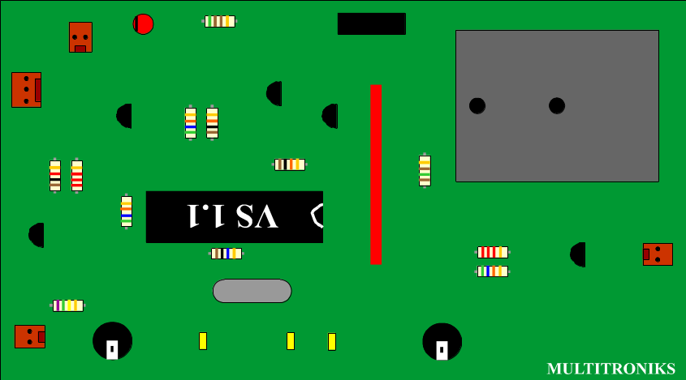IT IS CRITICAL TO CORRECTLY INSERT THE ELECTROLYTIC CAPACITORS, TRANSISTORS, LED, REGULATOR, CRYSTAL, AND IC SOCKET. ANY VARIATION WILL CAUSE MALFUNCTION AND DAMAGE TO CIRCUITRY.
DIAGRAM 1

